Solve the following
Loops example
1. Print the following patterns using loop :
a.
*
**
***
****

delimiter //
drop procedure displayTriangle;
create procedure displayTriangle(in num int)
begin
declare str1 varchar(100) default '*';
declare result varchar(100) default '\n';
declare count int default 1;
while count <=num do
set result = concat(result, str1, '\n');
set str1 = concat(str1,'*');
set count = count +1;
end while;
select result;
end //
delimiter ;

b.
*
***
****
***
*

delimiter //
drop procedure if exists displaydiamond;

create procedure displaydiamond(num int )
begin
declare str1 varchar(100) default "*";
declare result varchar(255) default "\n";
declare length int ;
set length = num/2;

while length <= num do
set result = concat(result,lpad(str1,length," "),"\n");
set str1 = concat(str1,"**");
set length = length +1;
end while;

set length = num-1;
set str1 = substr(str1,1,num-2);

while length >= ceil(num/2) do
set result = concat(result,lpad(str1,length," "),"\n");
set str1 = substr(str1,1,length(str1)-2);
set length = length-1;
end while;
select result;

end //
delimiter ;

c.
1010101
10101
101
1

d.
1
1 2
1 2 3
1 2 3 4
1 2 3 4 5

delimiter //

drop procedure if exists numberpattern;
create procedure numberpattern(num int )
begin
declare n1 int default 1;
declare result varchar(225) default '\n' ;
declare count int default 1;

while count <= num do

set result = concat(result," ",n1,'\n');
set n1 = concat(n1, count+1);
set count = count +1;

end while;
select result;
end //
delimiter ;

2. write a procedure to insert record into employee table.
the procedure should accept empno, ename, sal, job, hiredate as input parameter write insert statement inside procedure insert_rec to add one record into table
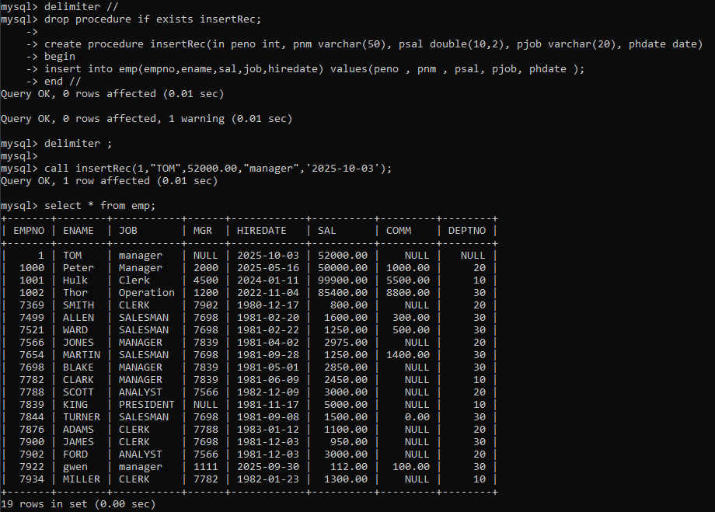

3. write a procedure to delete record from employee table.
the procedure should accept empno as input parameter.
write delete statement inside procedure delete_emp to delete one record from emp table

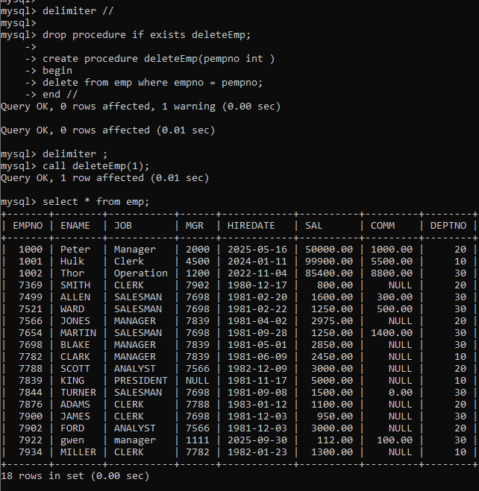

4. write a procedure to display empno,ename,deptno,dname for all employees with sal > given salary. pass salary as a parameter to procedure
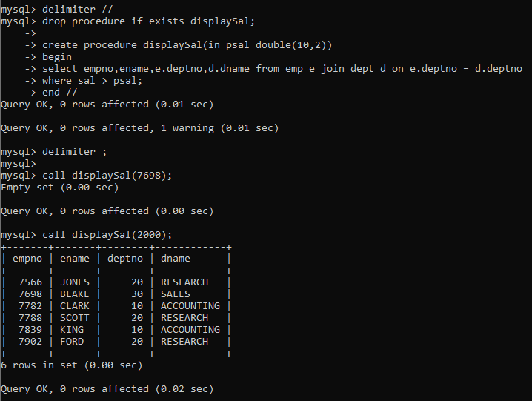

5. write a procedure to find min,max,avg of salary and number of employees in the given deptno.
deptno --→ in parameter
min,max,avg and count ---→ out type parameter
execute procedure and then display values min,max,avg and count

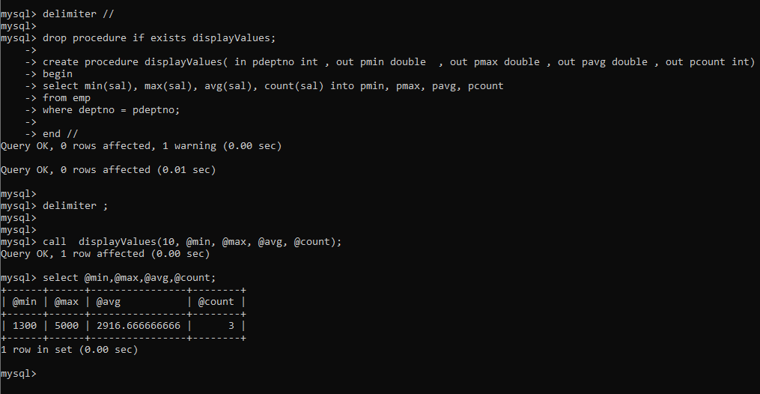

6. write a procedure to display all pid,pname,cid,cname and salesman name(use product,category and salesman table)

7. write a procedure to display all vehicles bought by a customer. pass customer name as a parameter.(use vehicle,salesman,custome and relation table)

8. Write a procedure that displays the following information of all emp Empno,Name,job,Salary,Status,deptno
Note: - Status will be (Greater, Lesser or Equal) respective to average salary of their own department. Display an error message Emp table is empty if there is no matching record.

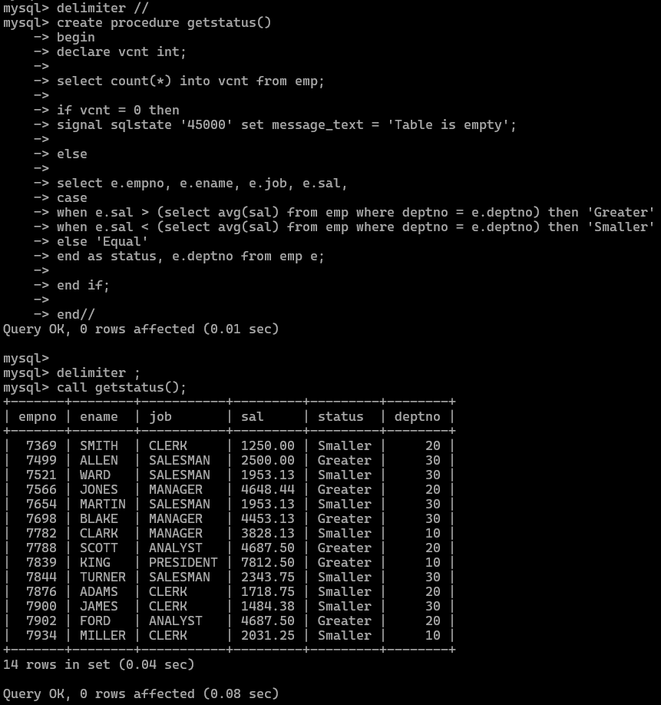

9. Write a procedure to update salary in emp table based on following rules. Exp< =35 then no Update
Exp> 35 and <=38 then 20% of salary
Exp> 38 then 25% of salary
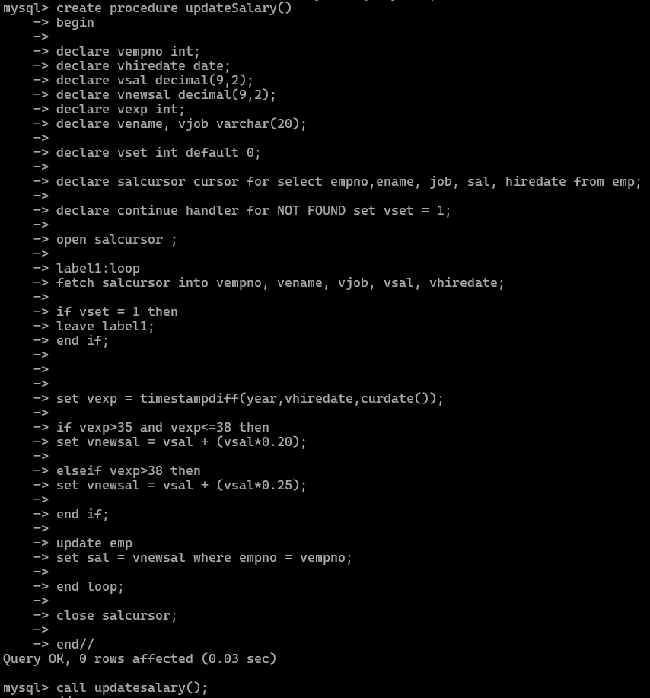
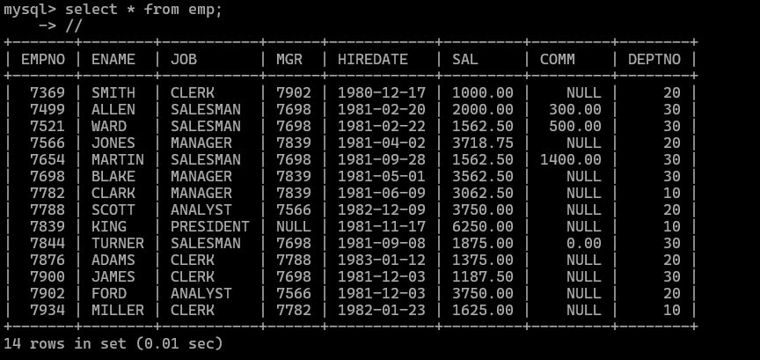
10. Write a procedure and a function.
Function: write a function to calculate number of years of experience of employee.(note: pass hiredate as a parameter)
Procedure: Capture the value returned by the above function to calculate the additional allowance for the emp based on the experience.
Additional Allowance = Year of experience x 3000
Calculate the additional allowance
and store Empno, ename,Date of Joining, and Experience in
years and additional allowance in Emp_Allowance table.
create table emp_allowance(
empno int,
ename varchar(20),
hiredate date,
experience int,
allowance decimal(9,2));
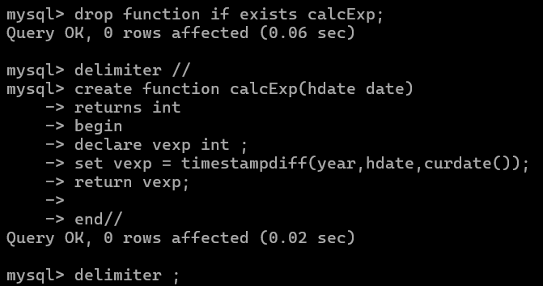
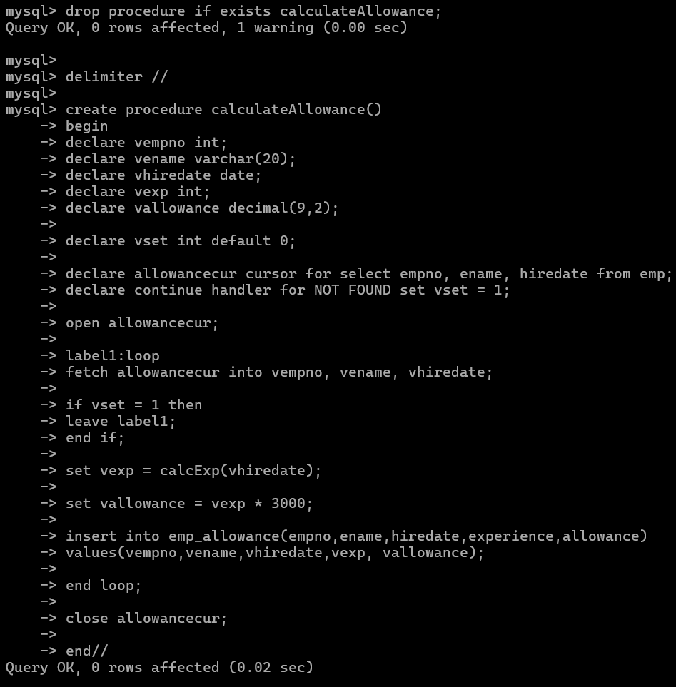
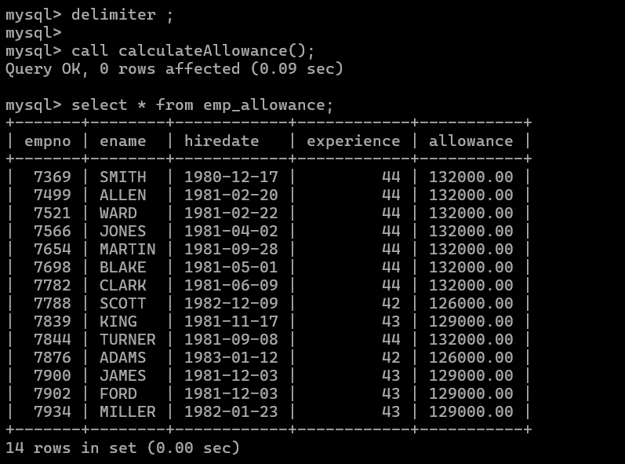

11. Write a function to compute the following. Function should take sal and hiredate as i/p and return the cost to company.
DA = 15% Salary, HRA= 20% of Salary, TA= 8% of Salary.
Special Allowance will be decided based on the service in the company. < 1 Year Nil
>=1 Year< 2 Year 10% of Salary
>=2 Year< 4 Year 20% of Salary
>4 Year 30% of Salary

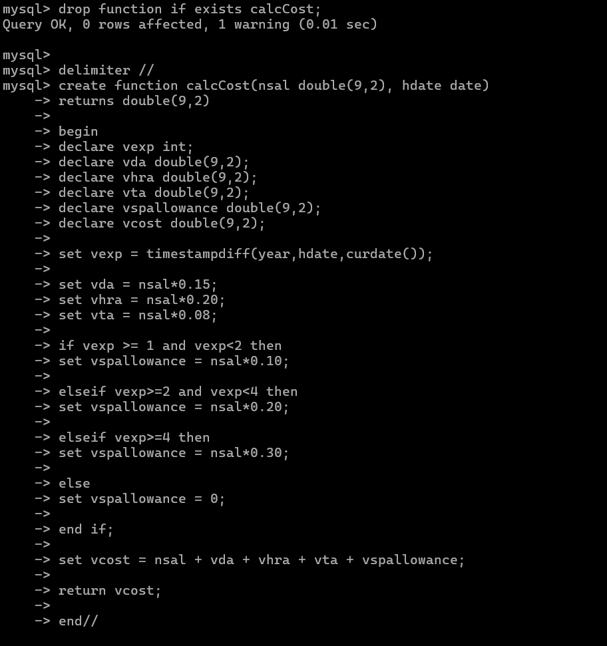
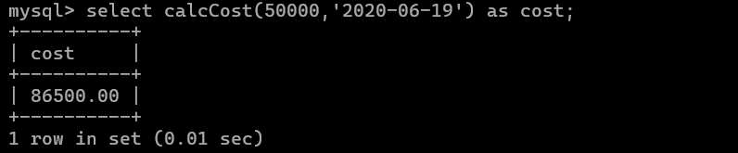

12. Write query to display empno,ename,sal,cost to company for all employees(note: use function written in question 10)
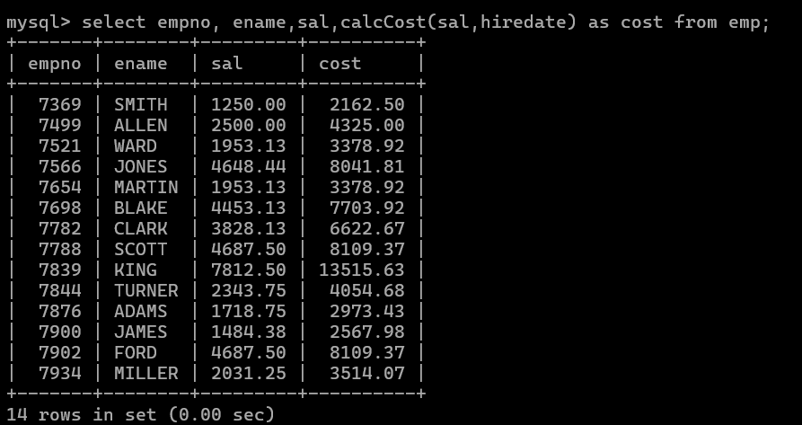

Q2. Write trigger
1. Write a tigger to store the old salary details in Emp _Back (Emp _Back has the same structure as emp table without any
constraint) table.
(note :create emp_back table before writing trigger)
----- to create emp_back table
create table emp_back(
empno int,
ename varchar(20),
oldsal decimal(9,2),
newsal decimal(9,2)
)
(note :
execute procedure written in Q8 and
check the entries in EMP_back table after execution of the procedure)

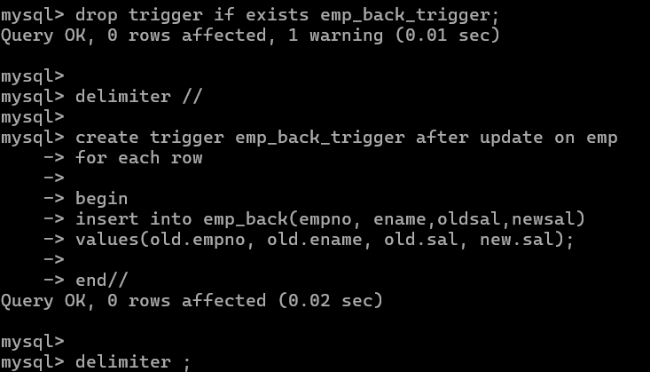
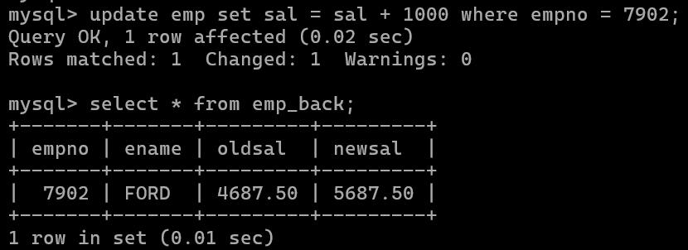
2. Write a trigger which add entry in audit table when user tries to insert or delete records in employee table store empno,name,username and date on which operation performed and which action is done insert or delete. in emp_audit table. create table before writing trigger.
create table empaudit(
empno int;
ename varchar(20),
username varchar(20);
chdate date;
action varchar(20)
);
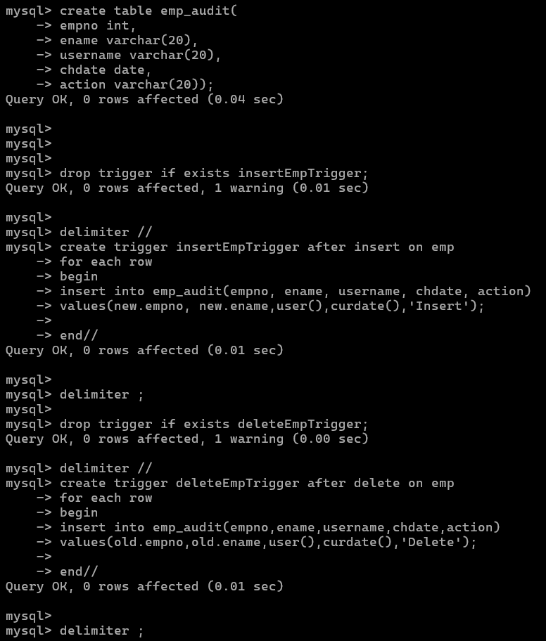
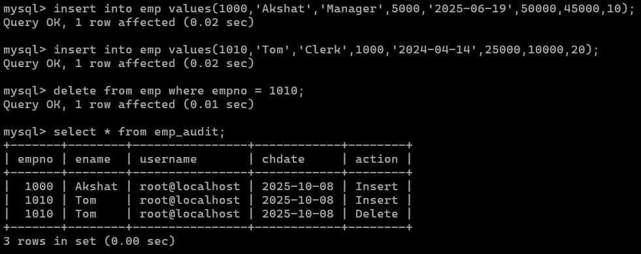

3. Create table vehicle_history. Write a trigger to store old vehicleprice and new vehicle price in history table before you update price in vehicle table
(note: use vehicle table).
create table vehicle_history(
vno int,
vname varchar(20), oldprice decimal(9,2), newprice decimal(9,2), chdate date,
username varchar(20) );

delimiter //
create procedure SwapName()
begin
declare temp varchar(20) default '';
declare pfn varchar(20);
declare pln varchar(20);
declare vset int default 0;
declare namecur cursor for select fn, ln from name;
declare continue handler for NOT FOUND set vset = 1;
open namecur;
label1:loop
if vset = 1 then
leave label1;
end if;
fetch namecur into pfn,pln;
set temp = pfn;
set pfn = pln;
set pln = temp;

update name
set fn = pfn and ln = pln
where 1!=2;

end loop;

end //
delimiter ;

